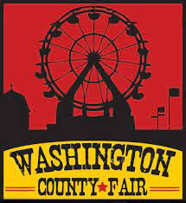

# 2024

**Washington County Born Steer Class / Washington County Fair**

This entry form must be turned in to or mailed to Jeremy Bailey/Sarah Bailey by Aug 1st.

Steer shown by:

Tag number or Identification:

1.) I testify that I am a beef producer in Washington County, Arkansas

1. I was the owner of the dam of this steer at the time of birth
2. The calf was born in Washington County

Producer name (please print):

Farm address or location:

Phone:

Producer signature:

Our Mailing Address:

Jeremy and Sarah Bailey

PO Box 256 Elkins, AR 72727